**Stress Learning Games**

**Iteration 4**

* Team members and roles
  + Hanyang Li (Product Owner and Programmer)
  + Ping Lu (Scrum Master and Game Testing)
  + Xin Hu (Programmer)
  + Zhiyu Yan (Programmer)
  + Chaoyang Zhu (Game Design)
  + Yipeng Lu (Programmer)
  + Mufeng Xie (Report Editor)
* Customer meeting data/time/place
  + Mondays 2020 Spring Semester, 1:00 – 2:00 pm, EABA
* Summary
  + Tasks that have been done:

Adapted hangman game into the stress-learning theme according to the requirement of the customer.

1. Changed the rule of the game from guessing a word per sentence into guessing multiple words per sentence. A sample screen shot of this game is illustrated below.

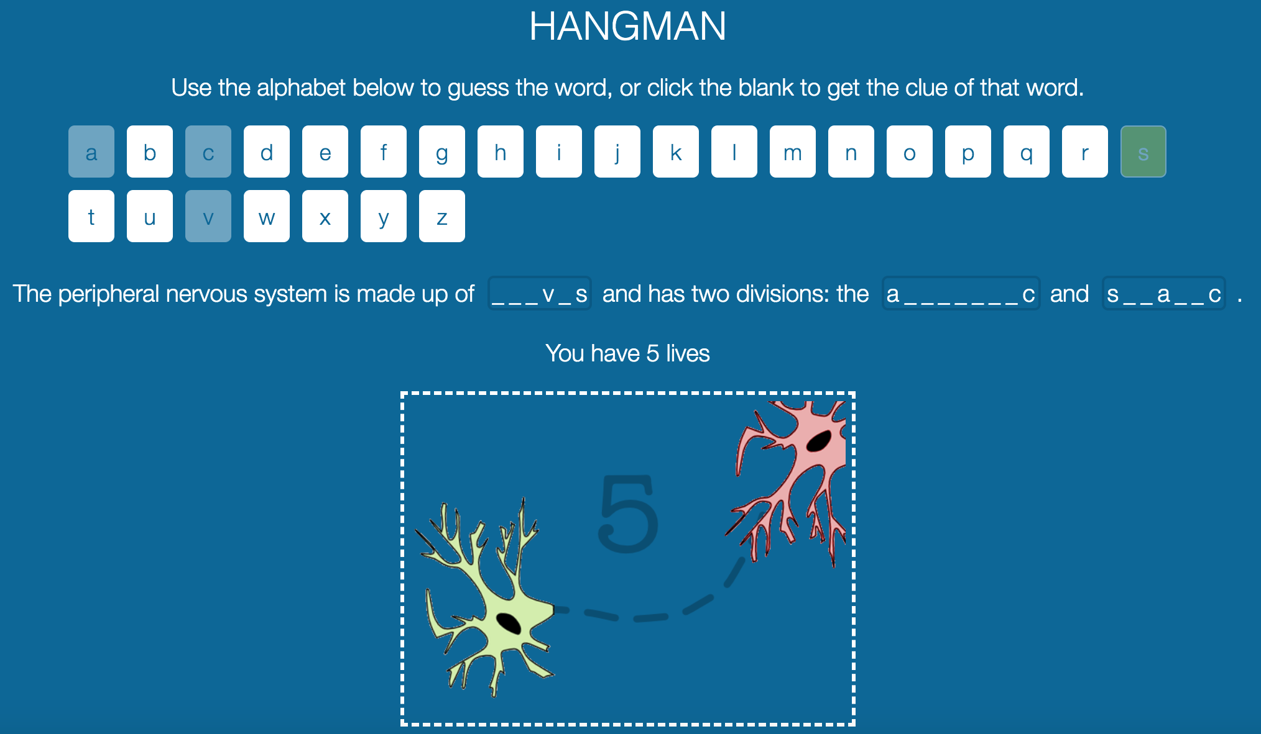

1. Extracted the words to be guessed, the corresponding hints and the related sentences, and put them into a file as configuration so that it can be modified according to the client’s needs and new rules.
2. Deployed the hangman game to the Stepstone development server. Now the customer can specify the words to be guessed and the hints according to their needs and test the gamer for their learning progress. A sample screen shot of the free form style game is illustrated below.

